ADMISSION CONTROLLER LAB:

We will:
- Create a namespace
- Enable Pod Security policy
- Create a dangerous Pod
- Watch Kubernetes reject it
This rejection is happening because of an Admission Controller.

kubectl get nodes
Step 2: Create Namespace
kubectl create namespace admission-demo
Verify:
kubectl get ns
Step 3: Enable Pod Security Admission
Apply label:
kubectl label ns admission-demo \
pod-security.kubernetes.io/enforce=restricted

Verify:
kubectl get ns admission-demo --show-labels

Expected:
pod-security.kubernetes.io/enforce=restricted

What Does This Mean?
Kubernetes Admission Controller now says:
Inside this namespace:
No root user
No privileged containers
No unsafe security settings

# Launching Dangerous pod
nano root-pod.yml

apiVersion: v1
kind: Pod
metadata:
name: root-pod
namespace: admission-demo
spec:
containers:
- name: nginx
image: ngin
securityContext:
runAsUser: 0

kubectl apply -f root-pod.yaml

Expected Output
You should see something similar to:
Error from server (Forbidden):
pods "root-pod" is forbidden:
violates PodSecurity "restricted"

What Happened?
Request flow:
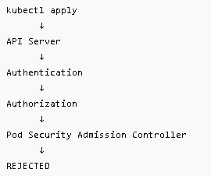

The Pod never reaches etcd.
The Pod never gets created.

Verify:
kubectl get pods -n admission-demo
Output:
No resources found
Admission Controller blocked it.
Step 5: Create Valid Pod
nano good-pod.yml
apiVersion: v1
kind: Pod
metadata:
name: good-pod
namespace: admission-demo
spec:
securityContext:
runAsNonRoot: true
containers:
- name: nginx
image: nginx

kubectl apply -f good-pod.yaml

kubectl get pods -n admission-demo
Expected:
good-pod Running

See Admission Controller in Action
Describe namespace:
kubectl describe ns admission-demo
You'll see:
pod-security.kubernetes.io/enforce=restricted
This activates the Admission Controller behavior for that namespace.

